

|  |  |
| --- | --- |
| **NAME** | **TP NUMBER** |
| ASLEY TAN WEI HAU | TP045392 |
| CHOW TUNG SENG | TP046010 |
| MAH WAI LING | TP046133 |
| CHANG CARDEE | TP045037 |

**Internet Applications Group Assignment**

**Intake Code**  : UCDF1704ICTSE

**Module Code** : AICT001-4-1-IA

**Lecturer Name** : Mr. Wong Chung Wei

**Date Assigned :** 13th MARCH 2018

**Date Completed** : 2rd MAY 2018

Contents

INTRODUCTION 3

WEBSITE DEVELOPMENT METHOD 4

LOGIN FORM 4

HTML 4

CSS 5

JavaScript 7

SCREENSHOTS 8

HOMEPAGE 8

SIGN-UP 9

LOGIN 10

ABOUT 11

BEGINNER LEVEL 12

INTERMEDIATE LEVEL 28

ADVANCED LEVEL 35

FORUM 44

NAVIGATION STURCTURE 46

CONCLUSION 48

REFERENCES 50

APPENDIX 52

# INTRODUCTION

Websites have become something that is frequently reoccurring in this day and age. When any one utters the word “Internet”, it is no exaggeration that most people would first think about a website, such as Google, Facebook, or even YouTube. This shows that the usage of websites is very dominant compared to a lot of other aspects of the Internet. There are many uses for websites, while some use it as a social network, a search engine, a video hosting site, as for the mentioned websites above, there are others who will use it for advertising, marketing, reviewing or even writing diaries called blogs. With the usage of websites multiplying each day, we will discover that most of the widely-used websites all have astonishing web designs, yet most people do not know about the structures and systems of how the website looks, or even how a website is built.

In this assignment we will learn and dive into the steps and systems of creating and designing a website. 3 languages will be used to develop the website, and they are HTML (Hypertext Markup Language), CSS (Cascading Style Sheets), and JS (JavaScript). The website will be called “BadmintonGeek”, which is a mockup of a forum/tutorial website that is mainly focused on the sport of Badminton. The development of the website should display and elaborate basic and fundamental knowledge of web designing, which is tantamount to a construction of a good-looking and well-structured website.

WORK BREAKDOWN STRUCTURE

|  |  |
| --- | --- |
| **Section** | **Member In-charge** |
| Index  About  Sign Up  Beginner Level: Tap  Beginner Level: Lift/ Lob | Asley Tan WeiHau |
| Intermediate Level: Drive  Intermediate Level: DropShot  Intermediate Level: Forehand Smash  Forum List | Chow Tung Seng |
| Advanced Level: Jumping Smash  Advanced Level: Backhand Smash  Advanced Level: Overhead Smash  Advanced Level: Defending Technique | Chang Cardee |
| Beginner Level: Serving  Beginner Level: Net Shots  Beginner Level: Gripping Technique  Beginner Level: Footwork & Positioning | Mah Wai Ling |
| Documentation | ALL MEMBERS |

# WEBSITE DEVELOPMENT METHOD

## LOGIN FORM

### HTML

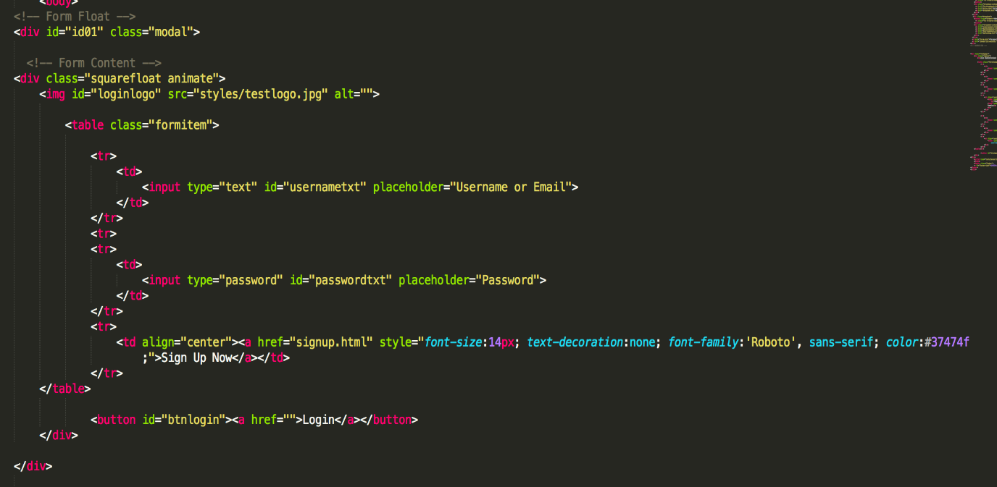

Figure 1.1

The login form is a floating section of the website that will be activated on the click of the login button in the top navigation bar. Once that is clicked, the form with the code as shown above will be displayed. The form has a large background made with a div that possesses the class of “modal” and the id of “id01”. Within that will be the main contents of the form that is also made by a div and possesses that class of “squarefloat” and “animate”. Within this div, there is an img element that shows the website logo and a table where all the input types are held to keep the form in order. After the table is the login button, which uses the button element and possesses the id of “btnlogin”.

### CSS

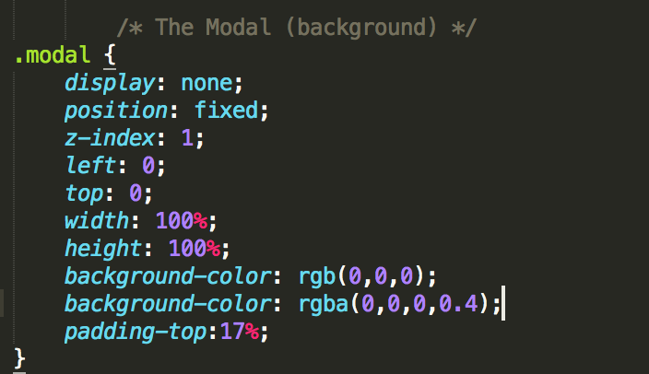

Figure 1.2

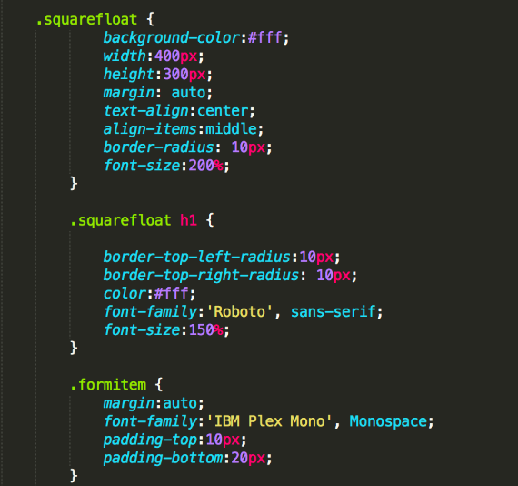

Figure 1.3

These are the visual adjustments made for the elements that are mentioned in the HTML section above. In Figure 1.2, the modal CSS class selector sets the Display property to “none”. So that the login form is hidden by default until the login button is pressed in the top navigation bar. The position is set to fixed so that the position of the login form does not change, and the z-index makes sure that the login form is above the current webpage, which makes the login form have a “floating” effect on the page. Other than that, is the width and height properties that makes sure the floating div covers the entire viewport. The background color sets up the color black and the padding-top property adds a little space on the top of the div where it is needed.

In Figure 1.3, the code deals with the main login form and its alignments, with the properties similar to the above mentioned, other different adjustments are the font-family property, which deals with a special selection of fonts, the font size, which changes the size of the wordings, and the border radii, which smoothens out and makes the borders of the form round.

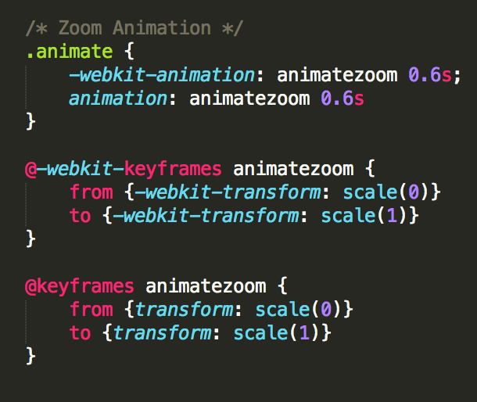

Figure 1.4

In Figure 1.4, there is the animation of the login form that executes every time the login form shows up. The animate class calls the animation called “animatezoom”, which is defined by the keyframe to transform the scale of the form from 0 to 1.

### JavaScript

Figure 2

The code snippet as show in Figure 2 is an example of how the login form displays itself. When the login button in the top navigation bar gets clicked, it calls the javascript function “loginPls()”, which then sets the display property of the element by the ID of “id01” to ‘table’ instead of ‘none’. The login form will then show itself on the page and be hiding no longer. The code below is then used to close (hide) the form once again. It listens to the clicking event on the window, when the user clicks on anywhere in the window, it will check if the event target is the modal variable, which is set to be the element by the id of “id01”. If this following condition is true, then the display property of the element will be set to “none”

# SCREENSHOTS

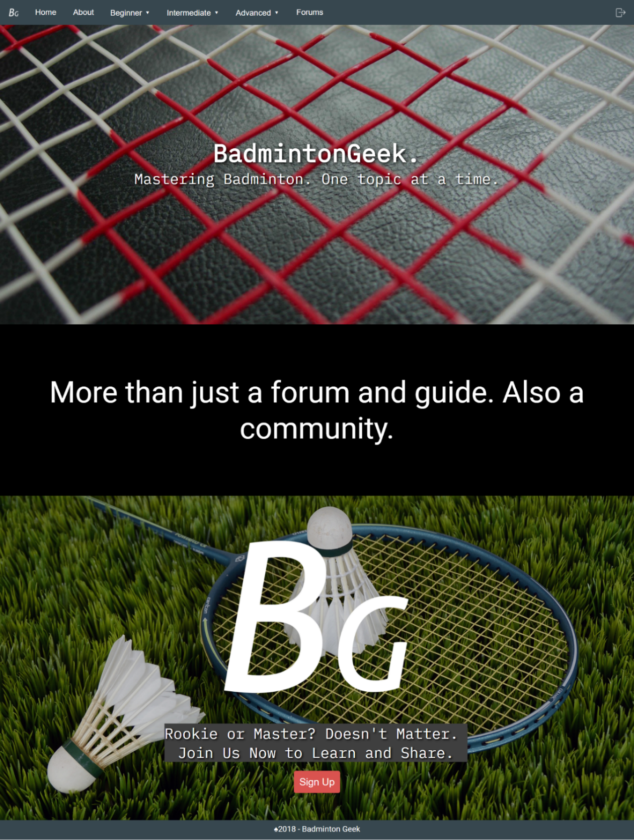HOMEPAGE

Figure 2:Home

This is the homepage of our website.

On the top of this page, there is a logo of BadmintonGeek followed by the navigation bar that includes Home, About, Beginner, Intermediate, Advanced and Forum. Then, there is a login button at the right side.

The background of the homepage is badminton related pictures. The homepage also shows our website name which is BadmintonGeek with our quote. It introduced to the visitor what is BadmintonGeek in few words. The bottom part of the page has the logo of BadmintonGeek in larger size and a “Sign Up” button.

## SIGN-UP

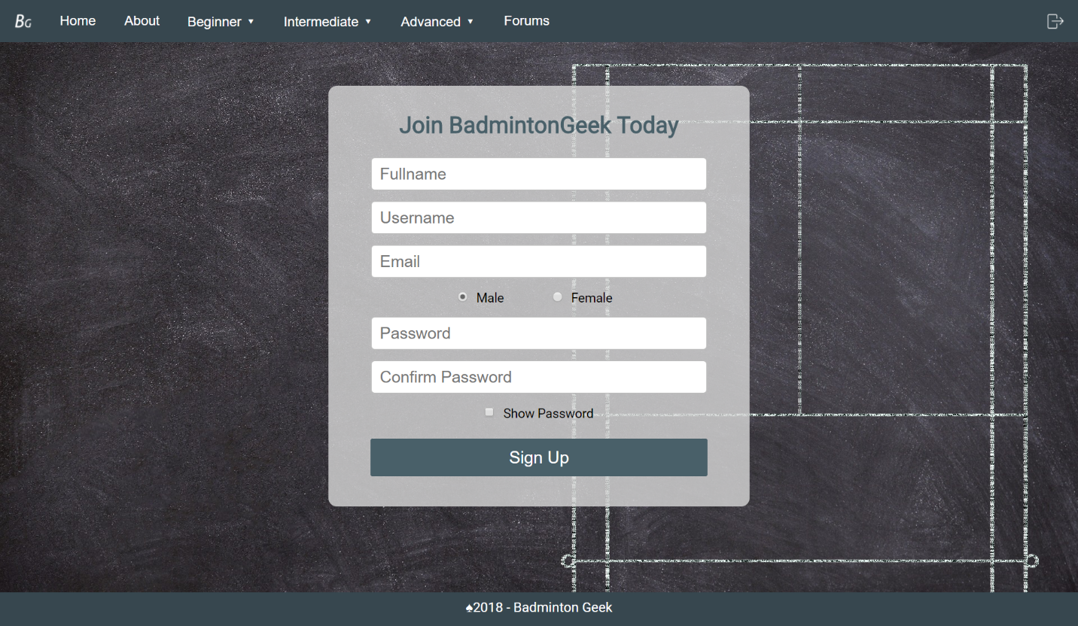

Figure 3: Signup

If the visitor is intrested to join BadmintonGeek, he/she just need to click on “Sign Up”button at the bottom of the homepage. A sign-up window will show up. In the Sign-Up page, there is a form for the visitor to fill in. In order to sign up to join BadmintonGeek, visitor is required to enter their fullname, username, email, gender and password.

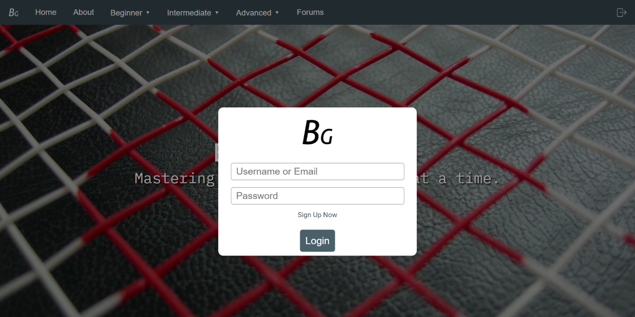LOGIN

Figure 4: Login

After signup as a member of BadmintonGeek, visitor can click on the login button at the right top corner in order to log in into BadmintonGeek. Then the login form will show, visitor can input their registered username or email and password and click on “Login”.

## ABOUT

Figure 5: About

In the About page, you will see our website name again “BadmintonGeek” at the obvious top section of the webpage. In the About page, visitor will have deep understanding to BadmintonGeek after reading all the information provided. About page tells the visitor who are BadmintonGeeks, what BadmintonGeek does and what is the mission of BadmintonGeek.

## BEGINNER LEVEL

Figure 6:Beginner Level

On the navigation bar, you will see there are three different levels which includes beginner, intermediate and advanced. When visitor is interested on the beginner related topics, he/she can click on “Beginner”. Then it will have the dropdown list as shown in Figure 5. Select the topic you want to find out more, a new window of the topic will show up.

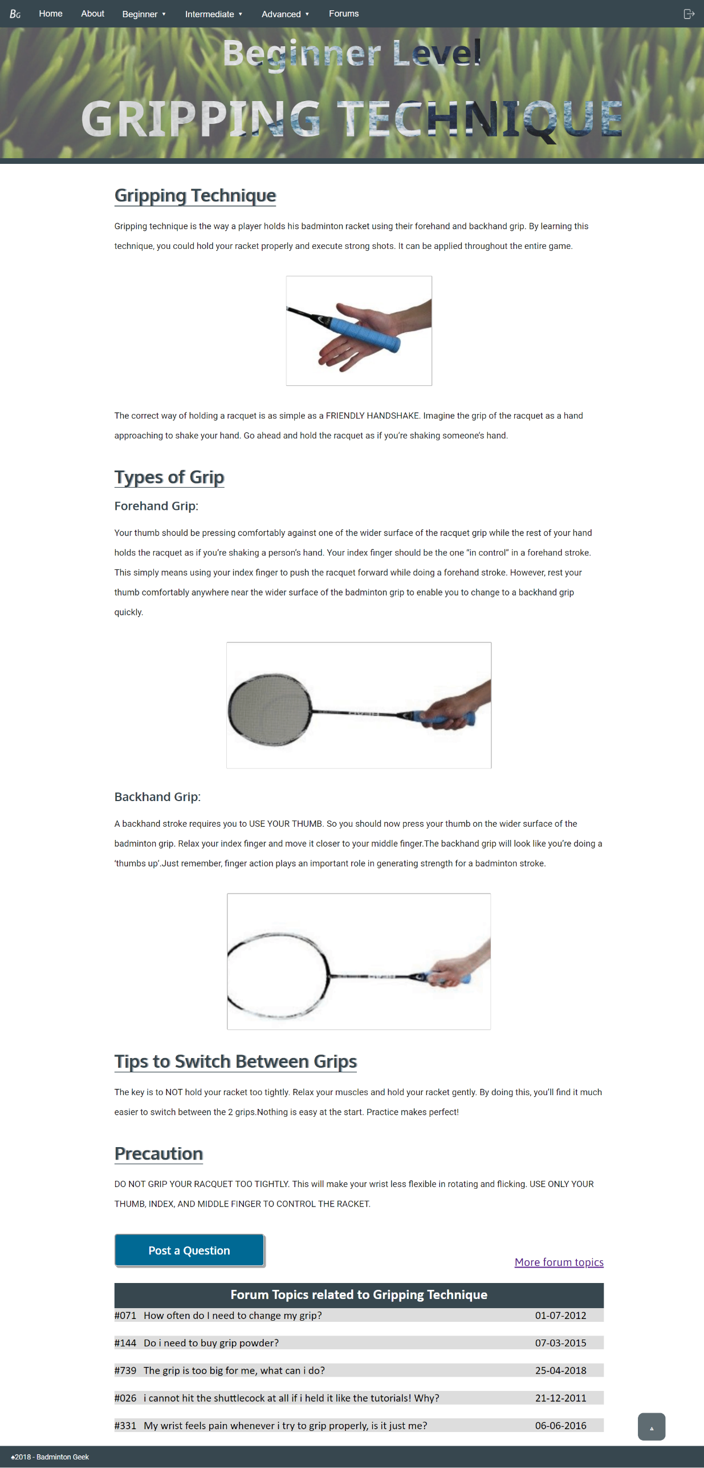

Figure 7:Beginner Level: Gripping Techechnique

On the Gripping technique webpage, you can see this topic is under beginner level as the header of this webpage had stated clearly the type of level and the topic.

In the content site, the title of this topic is again stated followed by the explanation of the topic. There is not only explanation in words, but we also provided in picture.

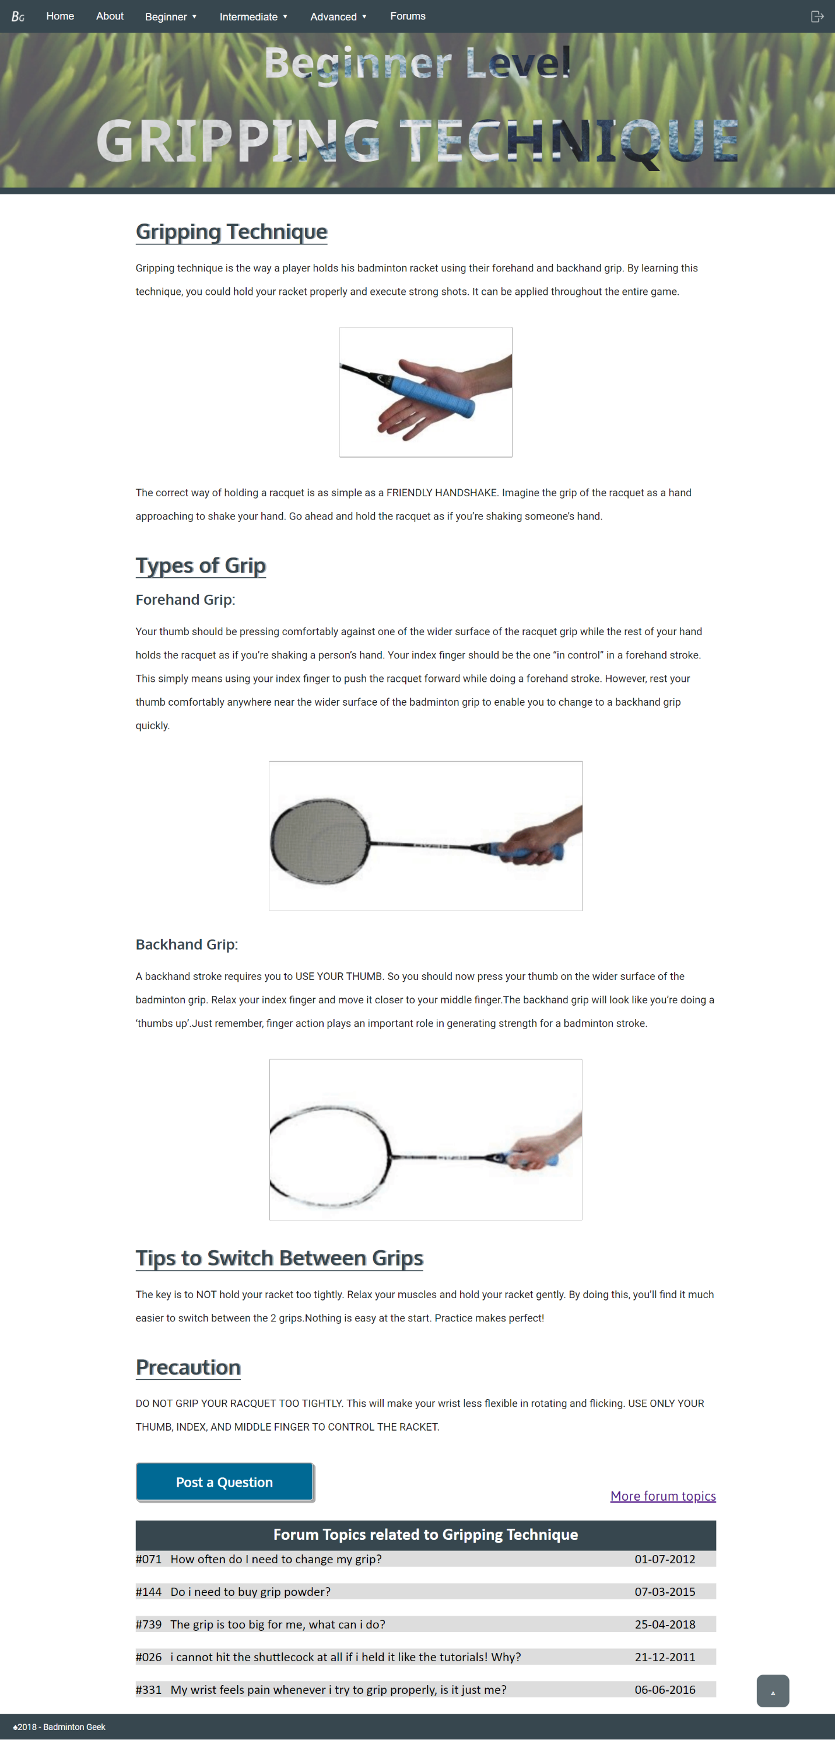It also shows there are two types of grip which are forehand grip and backhand grip. Each type of grip is explained in detail with picture attached.

Figure 8:Beginner Level:Gripping Technique

Besides, the webpage also provides some tips for the visitor how to switch between these two types of grip, some precautions and advices on what visitor should be more focus on.

In the end of this topic, if the reader has any question, they can click on the “Post A Question button” to ask the question in the forum. Visitors are advised to log in before posting any question on the forum. There is also list out the forum topics which are related to Gripping technique.

In order to back to the top of the webpage, visitor doesn’t require to scroll all the way up. Visitor just needs to click on the up arrow at the right button to back to the top.

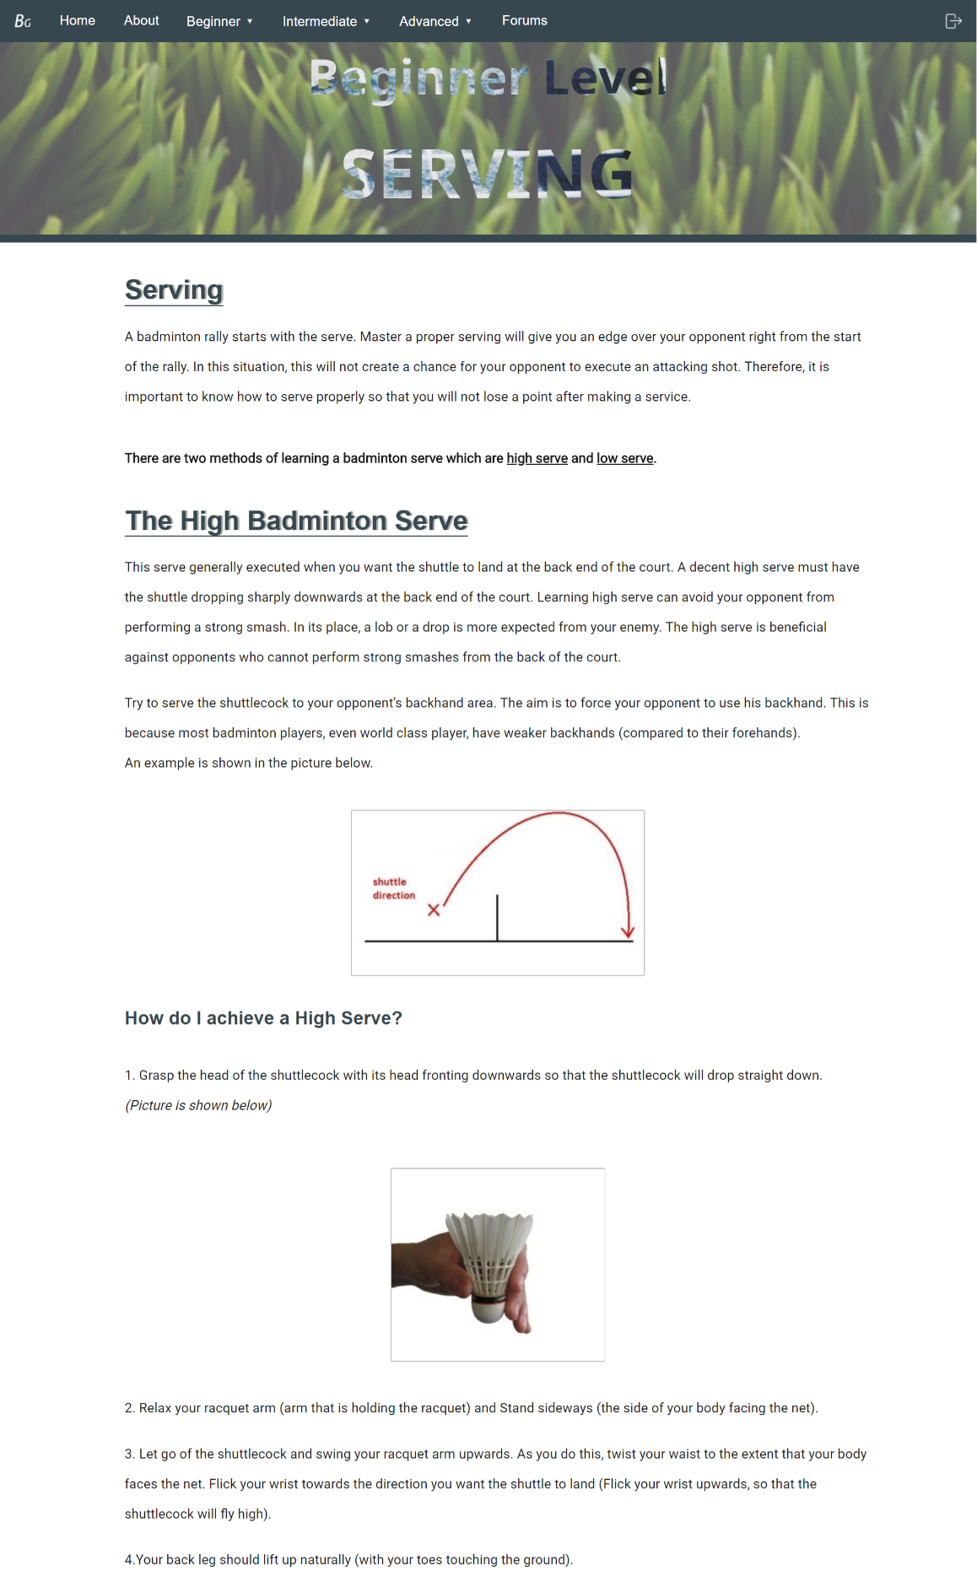

Figure 9:Beginner Level: Seving

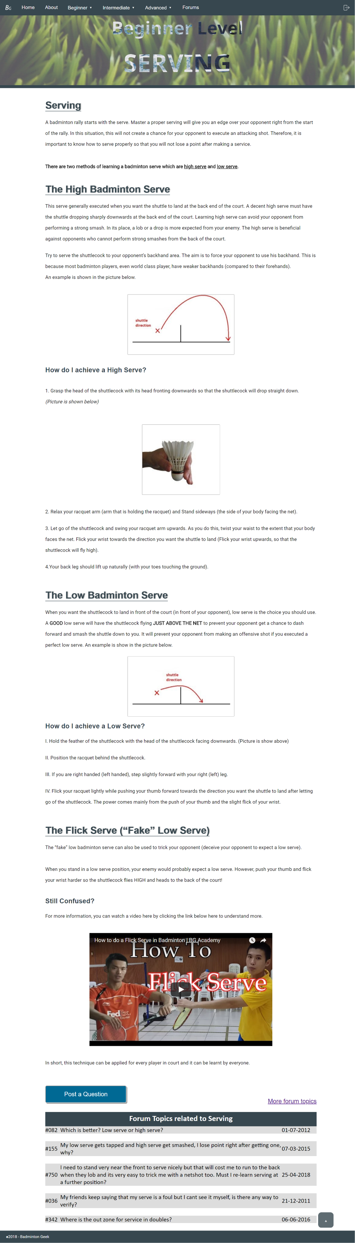

Figure 10: Beginner Level: Serving

Serving is one of the topics of beginner level. The title of this webpage and the level it belongs to will again state on top of the webpage. The introduction of serving will start the content part. As there are two methods for badminton serve which are high serve and low serve, so each method will be introduced in detail. High badminton serve, and low badminton serve are both explained with example in picture and there are simple tutorials for visitor. The tutorials are step-by step with pictures attached on it.

Besides these two methods, the webpage also provided additional information for serving. It provides some trick for the reader such as The Flick Serve which also known as Fake Low serve.

For those reader who are still confused about serving or need more information related to serving, there are also a video about Flcik Serving provided. They also can discuss the question by posting it on forum with just one click on “Post Question” or check on the forum topics related to serving.

This webpage also has the “Back to Top” function at the right bottom of the site. A click on it can back to the top of the webpage easily.

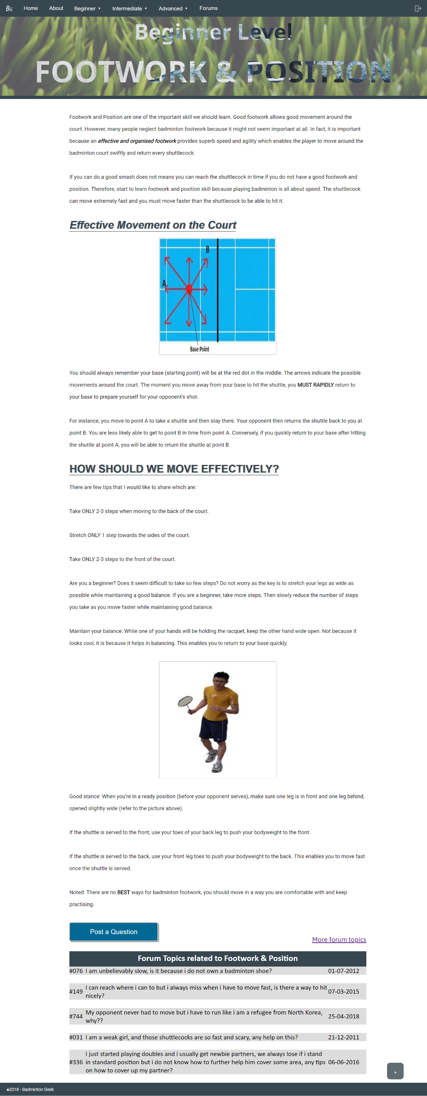Footwork and position are also very important when you are still a beginner in Badminton. The “Beginner Level” and the title “Footwork and Position” are both stated on the top of the site.

Figure 11: Beginner Level: Footwork &Position

Then the web page start with the importance of footwork and position to badminton and how they affect on you while playing badminton.

It also shows what is the effective movement on the court. With the clear explanation and picture, visitor can easily understand about effective movement on the court. After have the basic understanding of it, next there are tips for visitors on how to move effectively.

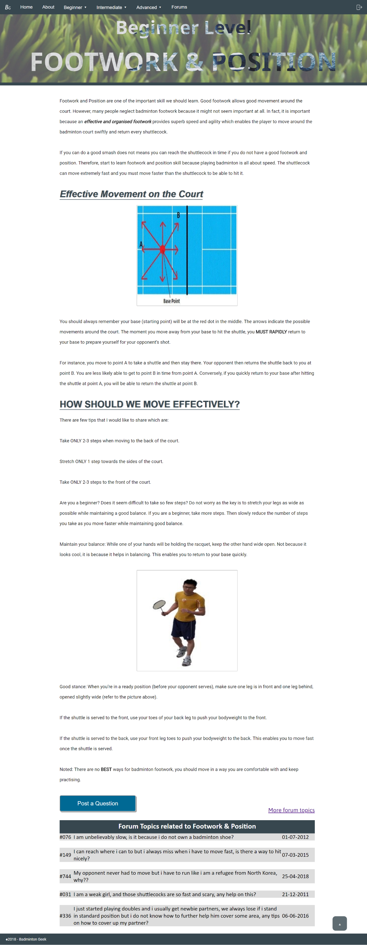The few tips provided are clear and easy to understand. It also considers as a beginner, it might be difficult to adopt it so there also some alternative ways for the beginner while they are trying for the badminton footwork. There is also picture for visitor to know exactly about what is ready position with detailed explanation. A reminder also provided for visitor in order to advise them about footwork and position while playing badminton.

Figure 12:Beginner Level: Footwork& Position

If visitors have question about Footwork and Position, the website has prepared for them to post question and discuss on forum. Hence, just click on “Post A Question” button to post your doubt about this topic.

The webpage also doesn’t require scrolling to back to the top of the page. As this can be done by simple clicking on the arrow button that provided at the right bottom of the page.

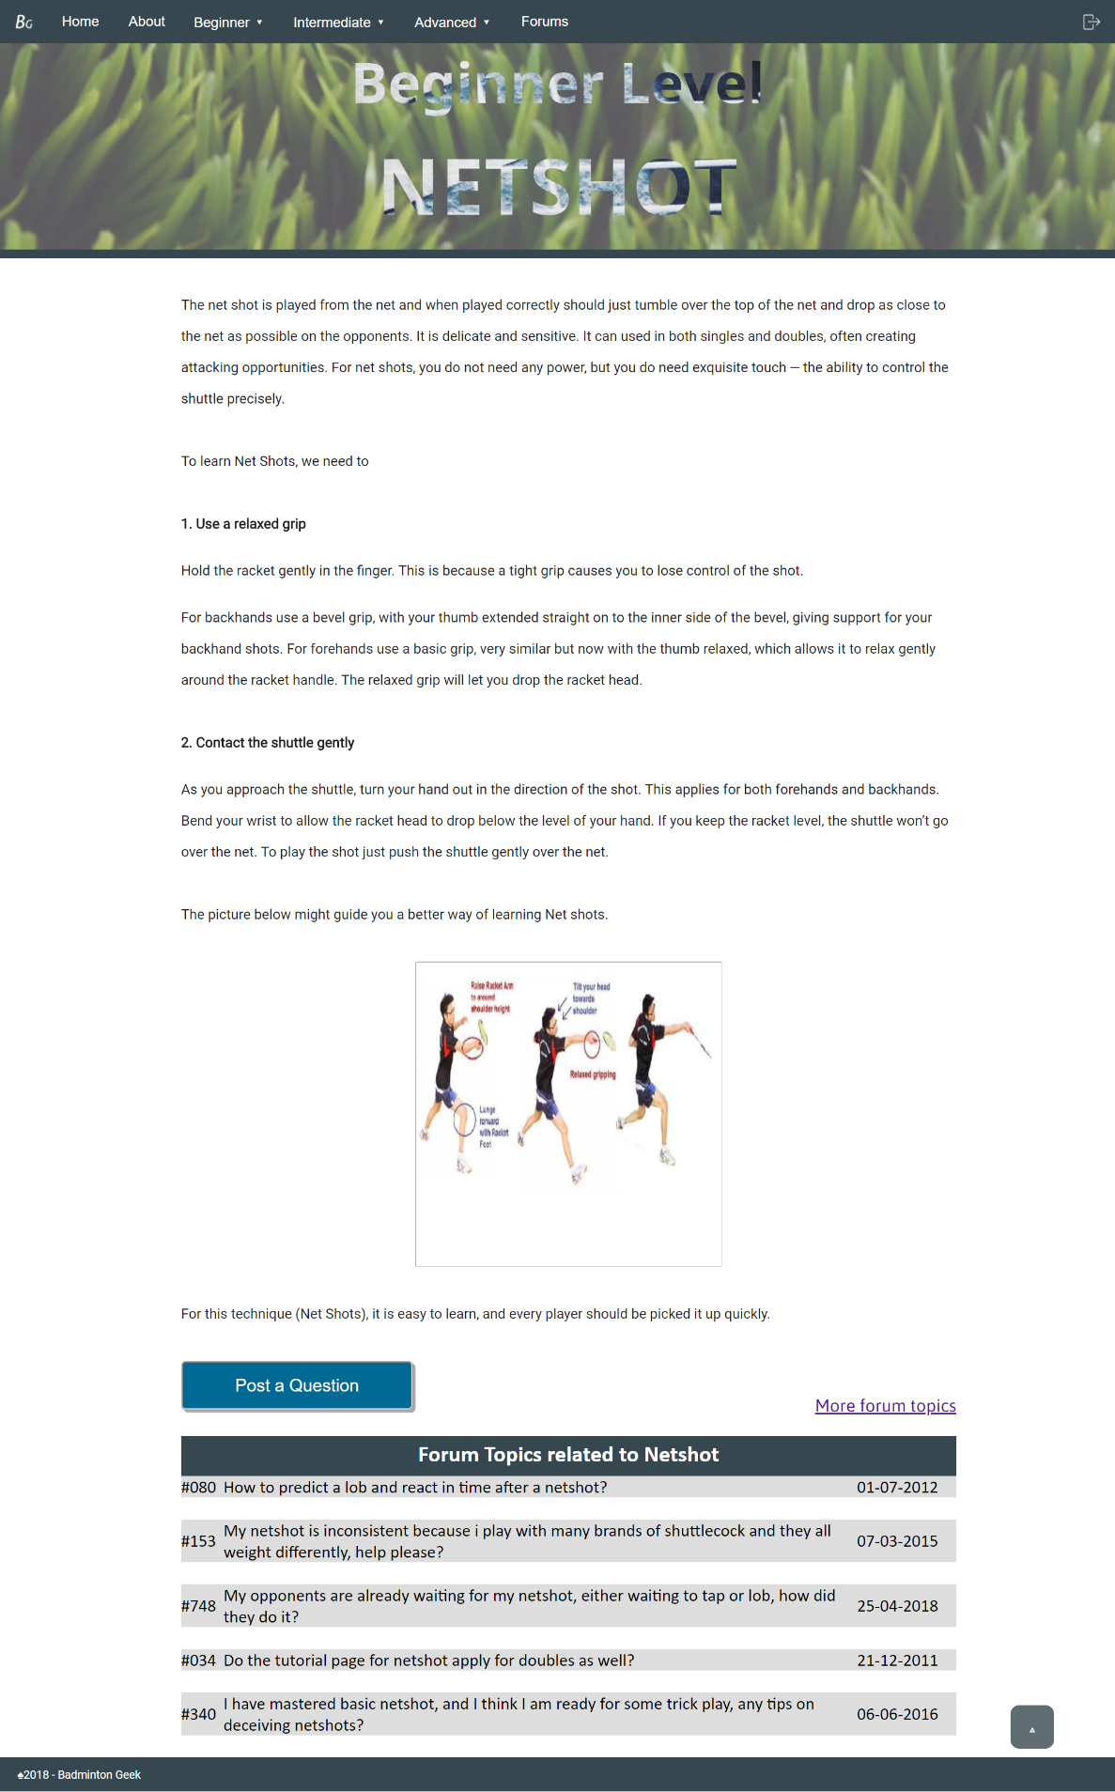Netshot is a basic technique that a beginner should master. As what previous webpage did, the level that Netshot is belongs to which is “Beginner Level” and the topic “Netshot” also shown at the top of the page.

Figure 13: :Beginner Level: Netshot

At the beginning of the page, you will know about what is Netshot as web page had explained it at first. To master Netshot, there are only two steps. Each of the steps has very detailed information and there is picture provided in order to guide reader in learning Netshot.

If reader still have any question or not so clear about Netshot, they are always welcome to click on the “Post a Question” button to post their question to forum that related to Netshot. They also can find the solution from the forum.

When you want to revise the information on top, you can just click on the arrow button to back to the top of the website which consume the time from scrolling all the way up.

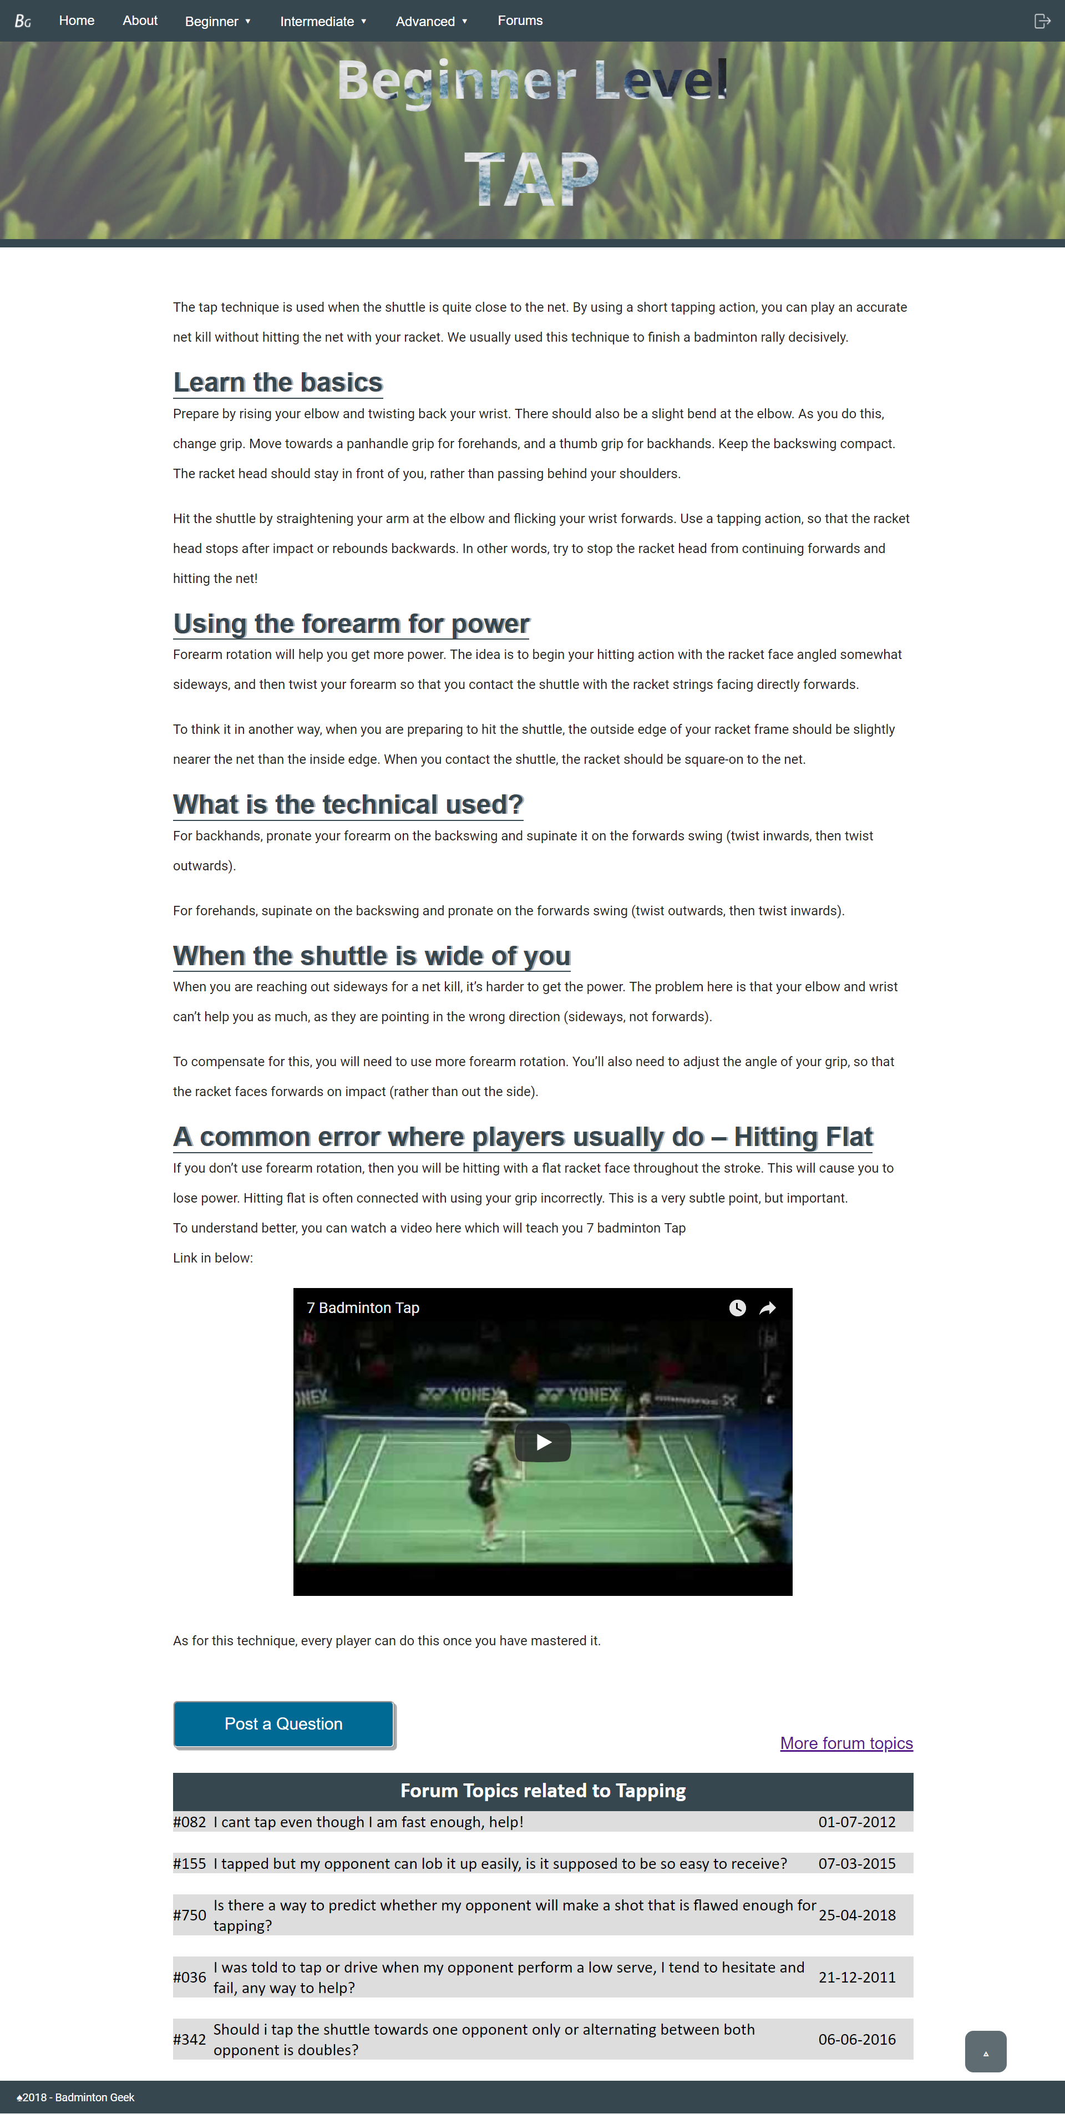.

Figure 14: :Beginner Level: Tap



Figure 15: :Beginner Level: Tap

Under beginner level there are so many techniques to be learned and one of them is Tap. As usual, on the top of the webpage there are “Beginner Level” and “Tap” indicate the topic of this webpage is Tap. At the beginning, the webpage described briefly what is tap and what is the function of this technique. The webpage is followed by the basic of Tap and how to perform this technique. It also mentioned that the forearm rotation is very important in Tap as it will help to gain more power.

The technical used in forehands and backhands gripping are different. Hence, the details of this are also clearly on the webpage. There are also different assumptions for the situation and there is solution for each situation the reader may face. At the end of the content, it mentioned about that Hitting Flat possible happen if the player doesn’t use forearm rotation in Tap. A video about tap also provided for visitor to have deeper understanding in Tap.

If visitor has any doubt or interested in this topic, they can discuss or post a question on forum by clicking on “Post A Question” at the bottom of the webpage. There is also “Back to Top” function available at the right bottom corner of the webpage for visitor’s convenience.

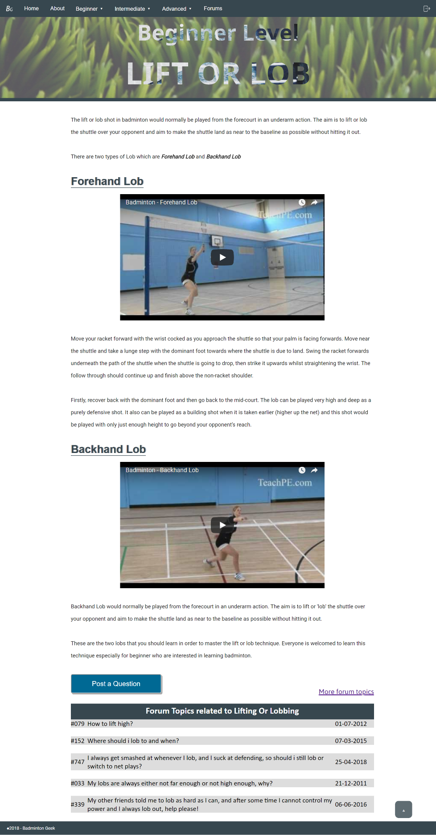

Figure 16: :Beginner Level: Lift or Lob

The last topic that will be discussed under beginner level is Lift or Lob. The title and the level of this topic are stated on top of the webpage.

In the content, there stated in which situation this technique will be used. Besides, the purposes of using this technique also shown at the beginning of the content.

There are two types of Lob and each types of lob are being explained in very detailed. The way of using this technique while playing badminton, which situation is more suitable for the lob and the uses of the lob are describe clearly. In case, the reader still not understand about both types of Lob, the webpage also provides videos for each lob.

In order visitors interested in this topic or have question, a button of “Post a Question” is provided at the bottom of the page. Visitor also can check the previous discussions in Forum that has related topic.

At the right bottom of the webpage, there is a small arrow provided for visitor to back to the top of the webpage easily.

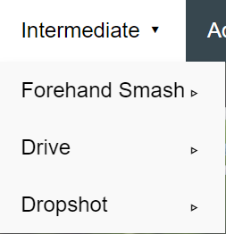INTERMEDIATE LEVEL

Figure 17: Intermediate Level

When visitor is interested on the intermediate level related topics, he/she can click on “intermediate” on the navigation bar. Then it will have the dropdown list as shown in Figure 16. Select the interested topic, a new window of the topic will show up.

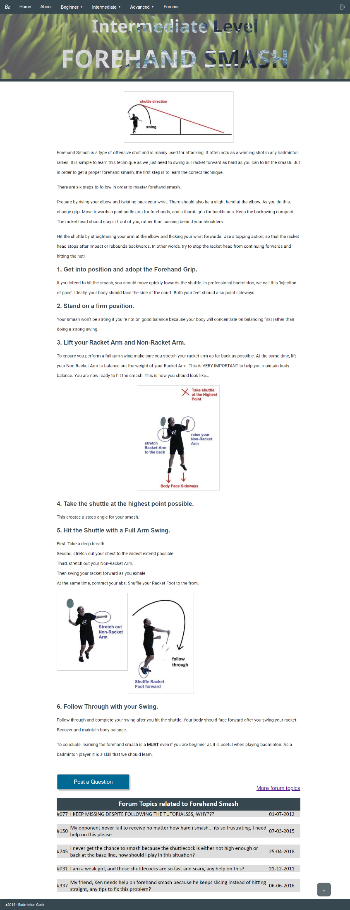

Figure 18:Intermediate Level: Forehand Smash

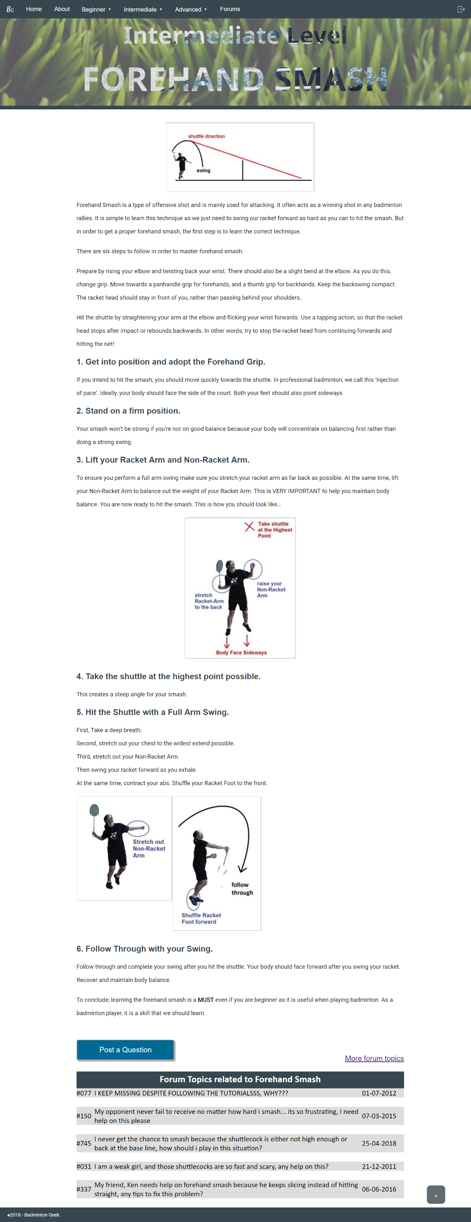In Intermediate Level there are three types of technique. One of the technique is Forehand Smash. The level of forehand smash and the title are stated on top of the webpage.

Figure 19: Intermediate Level: Forehand Smash

First, the webpage introduced you about forehand smash with a picture. From the picture, reader can know clearly what forehand smash is. Then, there are a very detailed introduction about this technique.

As to master forehand smash, there have six steps to follow. Each step is explained in brief but easy to understand. Some of the steps also have picture attached and some descriptions labeled on the pictures.

If the visitor still has any doubt to be solved, they are welcomed to click on the “Post A Question” button. Besides, they also can search for similar discussion from the forum. As other webpage, this webpage also has the back to top function. Visitor can just click on the arrow at the right bottom to back to the top of webpage.

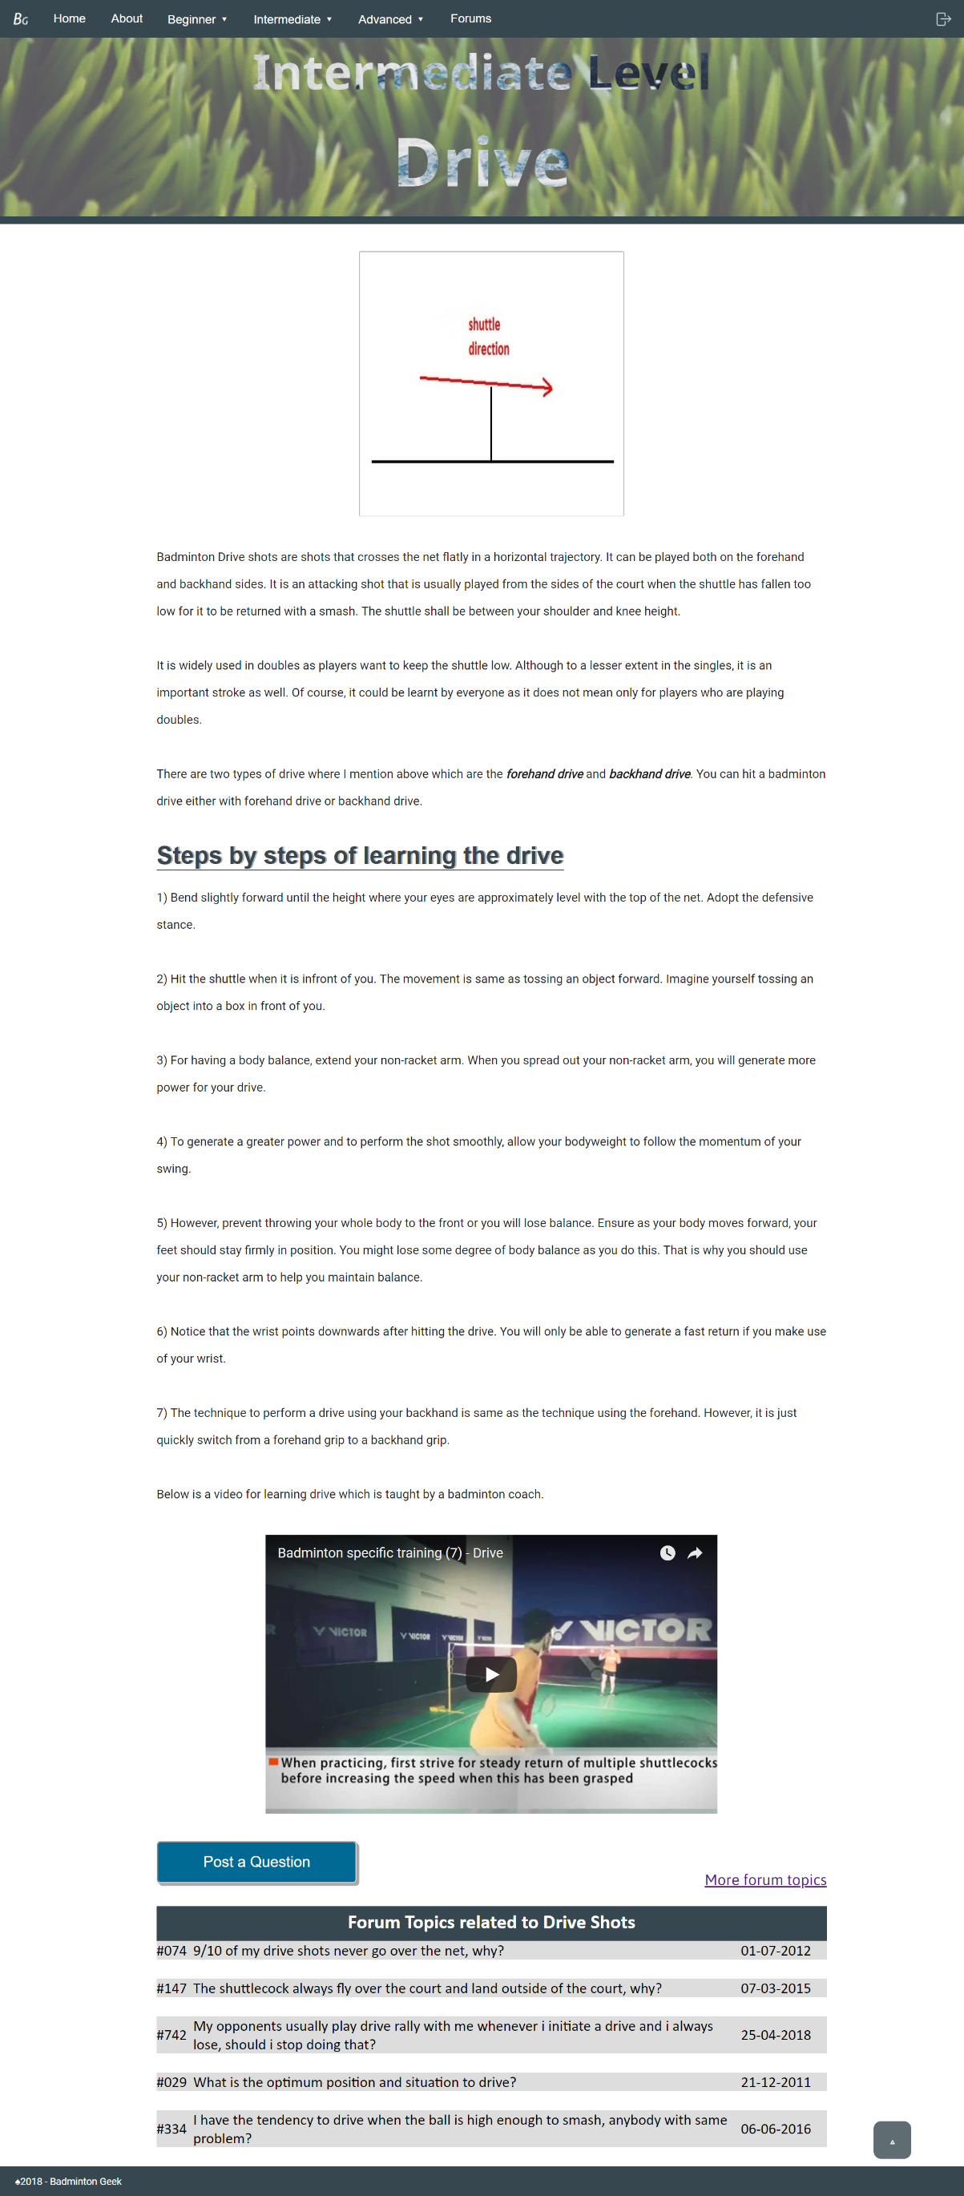

Figure 20:Intermediate Level: Drive

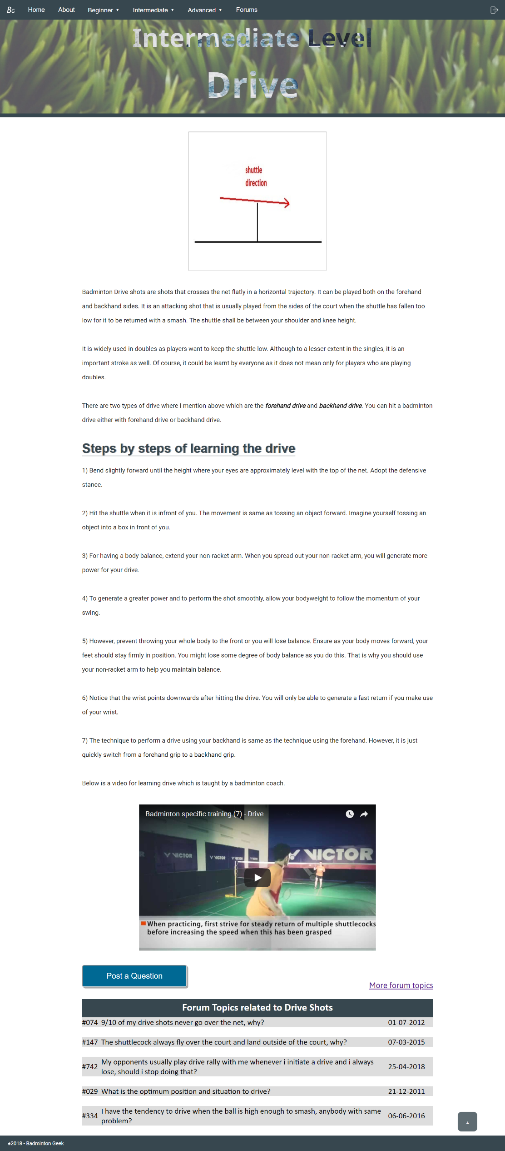The next topic that is under intermediate level is Drive.

Figure 21:Intermediate Level: Drive

“Intermediate Level” and “Drive” are both in the top of the webpage. A picture is attached with the introduction of Drive at the beginning of the webpage. There are two types of drive which are forehand drive and backhand drive. This technique not only used on player who plays double but also single.

In order to master Drive, there are seven steps to followed. Each step is explained clearly in the step-by – step tutorial. If the reader still not understanding about Drive, there is a video regarding drive technique training provided for them.

Reader can also choose to post a question by clicking on the “Post a Question” button or check on the previous forum to solve their doubt. There also doesn’t require scrolling to back to top as there is a small arrow provided at the right bottom corner. A simple click on the arrow can consume the time of visitor from scrolling the webpage.

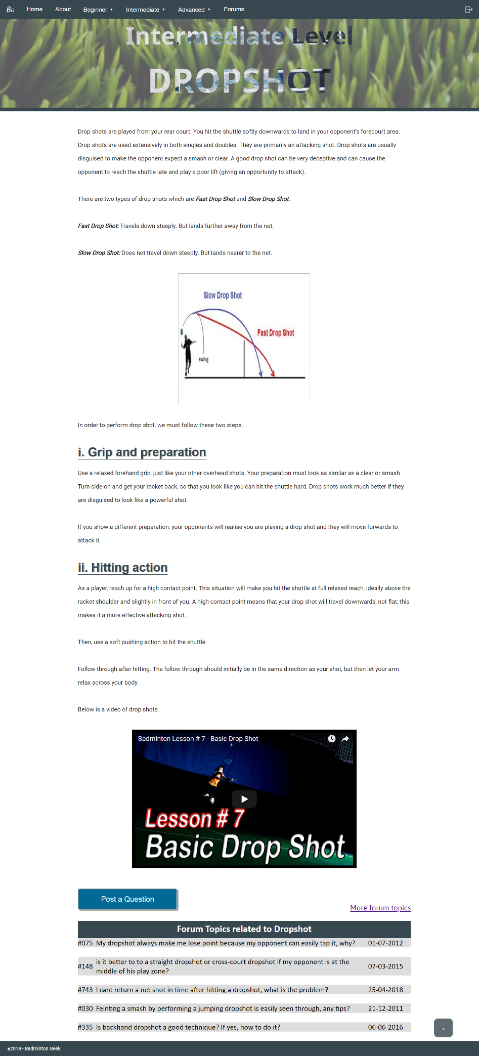

Figure 22:Intermediate Level: Dropshot

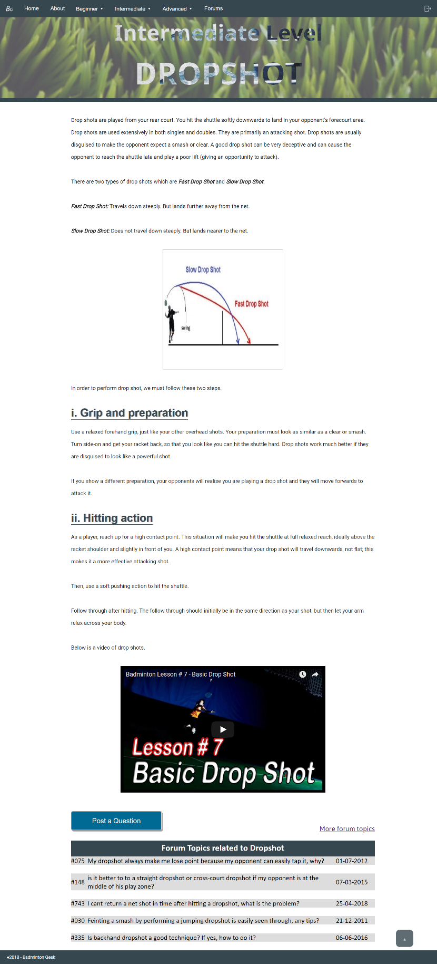Dropshot is the last topic in Intermediate Level. As previous webpage, the level of this webpage belongs to and the topic are shown at the top of the webpage. Then, the introduction of Dropshot. The introduction includes the uses of this technique and what is the benefit from a good dropshot. Besides, there are two types of drop shots which are Fast Drop Shot and Slow Drop Shot. Both drop shots are explained in briefly and there is a picture that shows the difference of these two types drop shot.

Figure 23:Intermediate Level: Dropshot

To perform a good drop shot, there are two ways to followed. These two ways are explained in detailed to let reader can understand them easily. The webpage also provides a short video regarding Drop Shot to ensure visitor has clearly understand about dropshot.

A “Post a Question” button also provided for visitors to post their doubt and discuss in the forum. There are also few forum topics that relate to dropshot shown.

The “Back to Top” function also unsurprisingly available in this page for the convenience of the visitor.

## ADVANCED LEVEL

Figure 24:Advanced Level

When visitor is interested on the advanced level related topics, he/she can click on “advanced” on the navigation bar. Then it will have the dropdown list as shown in Figure 23. Select the interested topic, a new window of the topic will show up.

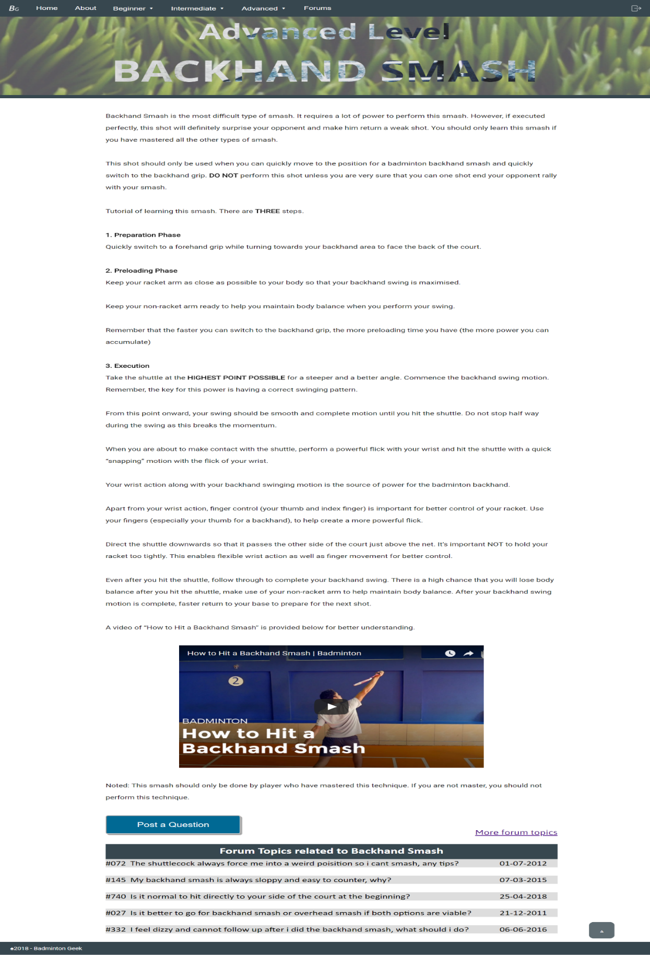

Figure 25:Advanced Level: Backhand Smash

This webpage titled “Advanced Level: Backhand Smash” is broken down into three sections, introduction, method of execution and example. The introduction summarizes what is a backhand smash, to allow readers to know if they are suited to learn it at their current level. The next part is categorizing method of executing a backhand smash into three steps which are preparation, preloading and execution, including step by step elaboration of the technique. A video of “how to hit a backhand smash” is provided as reference for the reader in the third section. Forum topics related to backhand smash are also designed into the webpage for readers who want to know more about this topic.

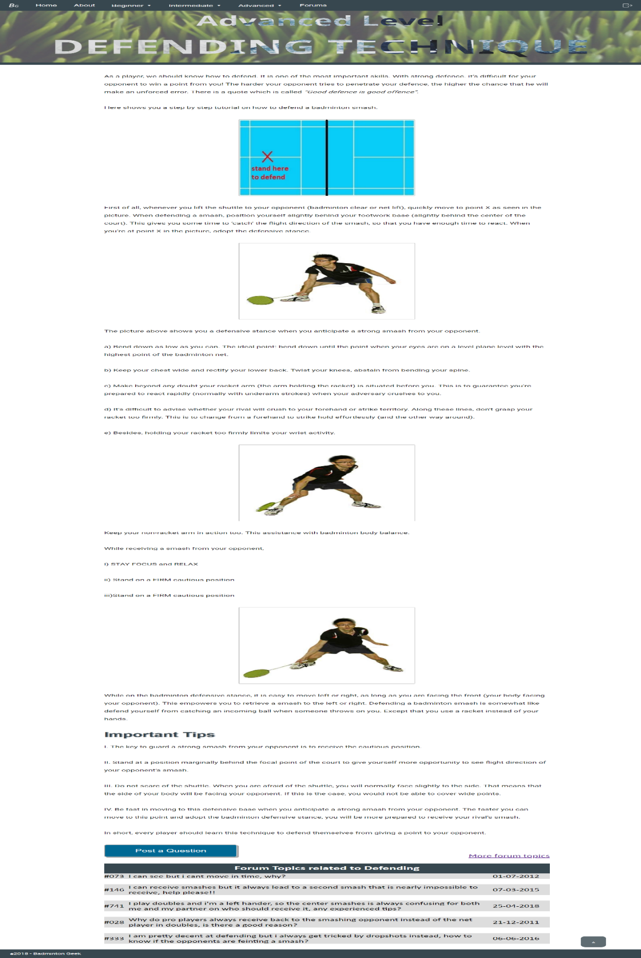

Figure 26: Advanced Level: Defending Technique

This webpage titled “Advanced level: Defending Technique” is broken down into three sections, which are introduction, step to step guide to defend properly and important tips when defending against a smash. Introduction is a brief explanation on significance of defending technique in badminton while step to step guide includes standard textbook defending method to defend against a wide range of smashes at once. The important tips are advices provided for beginners to avoid mistakes normally found in beginner when performing the technique. There are also forum topics related to defending technique at the end of the webpage for readers who wish to learn more about the defending technique.

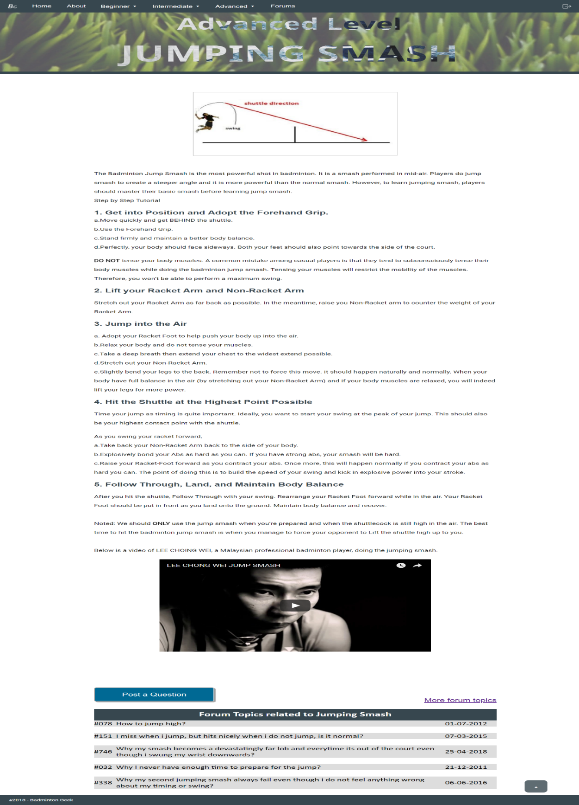

Figure 27: Advamced Level: Jumping Smash

The webpage titled “Advanced level: Jumping Smash” is divided into three sections, introduction, step to step guide for jumping smash and example of jumping smash. The introduction provides information on what is a jumping smash for reader to know what this webpage is about. The step to step guide provide multiple concise sentences or phrases for reader to slowly follow along easily. The example is a video of Dato Lee Chong Wei performing jumping smash as reference to what an ideal jumping smash looks like. There is also forum topics regarding jumping smash for further discussions among BadmintonGeek members.

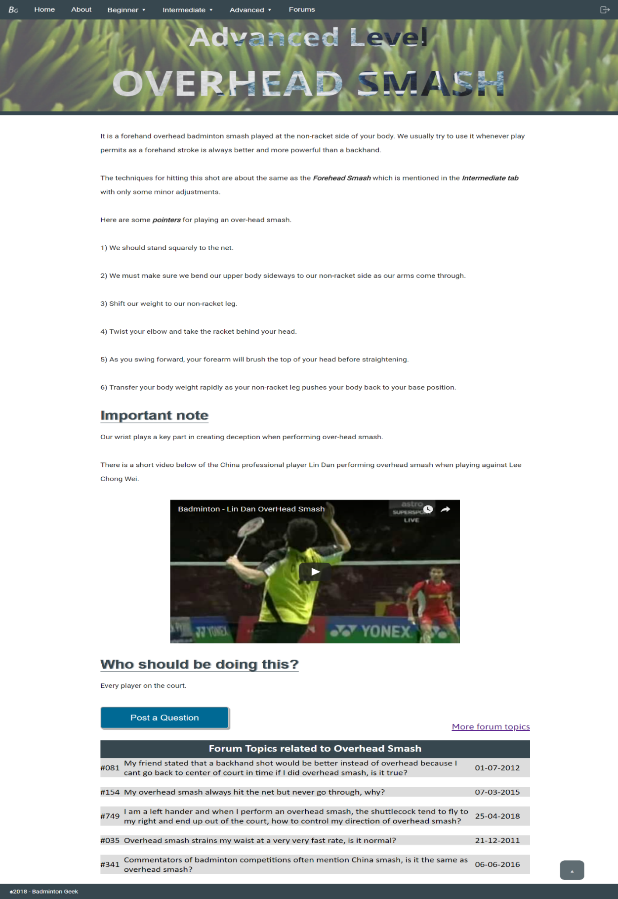

Figure 28:Advanced Level: Overhead SMash

The webpage titled “Over-head smash” is a webpage that is segmented into two segments, the first segment includes what is over-head smash and how is an over-head smash done while the second segment is the important key point to take note of when performing an over-head smash with a video of China’s top badminton player, Lin Dan as an ideal example. The end of the webpage includes forum topics related to overhead smash for others who may require help to obtain aid from other BadmintonGeek members.

## A screenshot of a cell phone Description generated with very high confidenceFORUM

Figure 29: Forum List

The webpage titled “Forum List” is a list of all the forum topics for readers to browse through and look for intriguing or interesting topics to learn more about badminton. Each page has 10 forum topics each page with a previous and next button to navigate between pages for more clarity when reading the page without the need to keep on scrolling .

# A screenshot of a cell phone Description generated with very high confidenceNAVIGATION STURCTURE

Figure 30: Navigation Structure

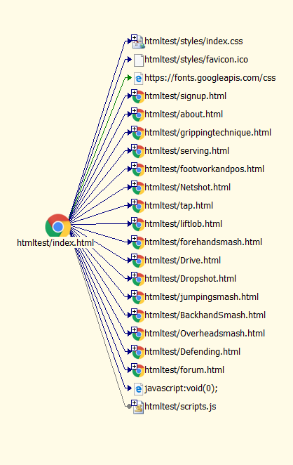

Figure 31:Site View Hyperlink

# CONCLUSION

This project is the coalescence of seventeen webpage and one form into a single website that aims to provide detailed information about badminton using simple sentences for web user to easily understand and prevent user from losing interest due to long-winded paragraphs. This project is a modern, easy to navigate website where every webpage is straightforward and only has a specific title to talk about.

The homepage of this website, BadmintonGeek, includes a parallax effect to allow users to experience the element of modern website and understand out motive through simple phrases. The signup button is also developed at the end of homepage for users to sign up after browsing through the homepage.

The about page is a simple webpage that is designed to fully focused on explaining what is BadmintonGeek and what is the aim of this website. This is done by providing a dark background and bright font to tell users that the only thing to see in this webpage is the few sentences provided in this page.

The forum webpage is a webpage that consist of all forum topics posted by BadmintonGeek members for other members to leave comments and give their personal opinions for members to gain more knowledge through discussions. The forum topics are navigated through a simple previous and next button so that users can browse through forum topics without the need to keep on scrolling. Each topic are also designed to have a slightly darker background in the whole row to highlight the topic row.

The content pages are of website includes thirteen tutorial webpages of beginner, intermediate and advanced level of guide. These webpages are designed so that all the contents are shown only in the middle of the page to let users read easier without having to scan left and right all the time and the headers are made to be more prominent to show users what subtopic they are reading. Images and videos that are aligned at centre of the webpage with a standard size for users to catch user’s attention and ease of view. A forum section is also provided to allow users to discuss and obtain more information regarding the topic of the webpage in the end of every content webpage. The content pages also include a “to-the-top” button which will appear when users scroll down so that it is easier to navigate across webpages instead of scrolling back up when user is done reading.

As a conclusion, this website can be built by using a database of members and forum topics and regular updates to maintain website after deploying as the structure and design is of decent quality and should be satisfactory for a new website.

# REFERENCES

W3Schools, n.d. *How TO - Login Form.* [Online]   
Available at: https://www.w3schools.com/howto/howto_css_login_form.asp  
[Accessed 14 April 2018].

W3Schools, n.d. *How TO - Toggle Password Visibility.* [Online]   
Available at: https://www.w3schools.com/howto/howto_js_toggle_password.asp  
[Accessed 14 April 2018].

W3Schools, n.d. *How TO - Parallax Scrolling.* [Online]   
Available at: https://www.w3schools.com/howto/howto_css_parallax.asp  
[Accessed 14 April 2018].

W3Schools, n.d. *CSS Rounded Corners.* [Online]   
Available at: https://www.w3schools.com/css/css3_borders.asp  
[Accessed 14 April 2018].

W3Schools, n.d. *CSS Selector Reference.* [Online]   
Available at: https://www.w3schools.com/cssref/css_selectors.asp  
[Accessed 14 April 2018].

Mozilla, n.d. *Event Listener.* [Online]   
Available at: https://developer.mozilla.org/en-US/docs/Web/API/EventListener  
[Accessed 15 April 2018].

Mozilla, n.d. *scroll - Event Reference.* [Online]   
Available at: https://developer.mozilla.org/en-US/docs/Web/Events/scroll  
[Accessed 15 April 2018].

CSS Tricks, n.d. *How to do Knockout Text.* [Online]   
Available at: https://css-tricks.com/how-to-do-knockout-text/  
[Accessed 16 April 2018].

W3Schools, n.d. *CSS Navbar.* [Online]   
Available at: https://www.w3schools.com/css/css_navbar.asp  
[Accessed 15 April 2018].

W3Schools, n.d. *CSS Pseudo Classes.* [Online]   
Available at: https://www.w3schools.com/css/css_pseudo_classes.asp  
[Accessed 15 April 2018].

W3Schools, n.d. *CSS Pseudo Elements.* [Online]   
Available at: https://www.w3schools.com/css/css_pseudo_elements.asp  
[Accessed 18 April 2018].

# APPENDIX